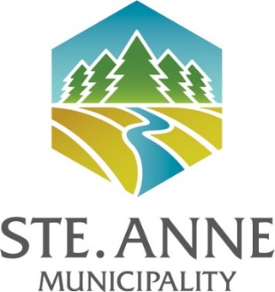

EMPLOYMENT OPPORTUNITY
Public Works Employee

The RM of Ste. Anne is accepting applications for the permanent full-time position of Public Works Employee to perform various duties under the direction of the Operations Manager.

Responsibilities:
Operating various equipment as required to complete tasks. Performing physical labour related to the Municipality’s maintenance program such as, but not limited to, asphalt repair, grass and brush cutting/trimming, sign maintenance, washing equipment and vehicles and general maintenance of the public works shop and yard other tasks as assigned.

A copy of the full job description may be obtained by consulting the website at www.rmofsteanne.com or by contacting the Municipal Office, 204-422-5929.

Desired Qualifications:
- Municipal and Public Works experience, including knowledge of relevant Manitoba regulations and guidelines
- Relevant mechanical & technical skills
- Class 3 or ability to obtain within 6 months
- Good public relations and communication skills
- Ability to work both in a team and independently under minimal supervision and make decisions in an accurate and consistent manner
- Excellent work ethic, including the ability to prioritize tasks and meet strict deadlines
- Valid Class 5 driver’s license with a clean record

Hours of work: Monday to Friday, 7:30 am to 4:30 pm including one-hour unpaid lunch break. Some overtime or call-in should be expected for weather events or other urgent matters.

Wages:
- In accordance with the Municipal Salary Scale for this position.

Please forward resumes marked “Public Works Employee Resume” and three work-related references by June 28, 2024 to pw@rmofsteanne.com or to:
Kevin Medeiros, Operations Manager
RM of Ste. Anne
395 Traverse Road; Box 6 Grp 50 RR1; Ste. Anne, MB R5H 1R1

Ste. Anne Municipality welcomes applications from people with disabilities. Applicants may request reasonable accommodations related to the materials or activities used in the selection process by making an advance request to pw@rmofsteanne.com.
Ste. Anne Municipality wishes to thank all candidates for their interest, but only those considered for an interview will be contacted.

